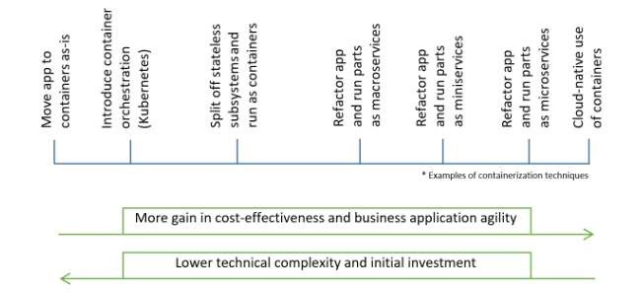**CONTAINERIZE THE APP** TEAM ID : PNT2022TMID12244

